Amy Clements
Artistic method: I enjoy using others leftover scraps and giving them new life in my art quilts using methods from big stitch hand quilting to water soluble stabilizer.

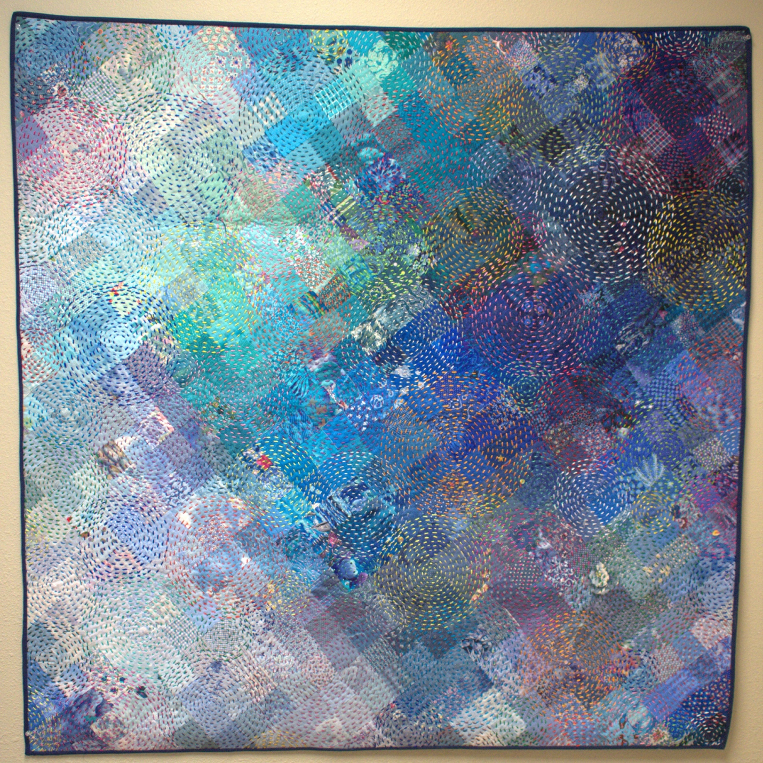
Water Ripples by Amy Clements

